Design Exercise

ENGN4511: Composite Materials

Patrick Wilton | u6050506

Sem2 - 2019

# Worked Problems

## Question 1:

1. Using the following set of variables:

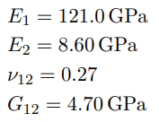

As well as the laminate orientation: [0/30]s of 0.25mm thick carbon/epoxy laminae; Classical Lamination Theory (CLT) can be used to determine the maximum bending moment Mx.

The first step in calculating the CLT stiffness matrix is calculating the values of the Lamina Stiffness Matrix which is done from the following set of equations:

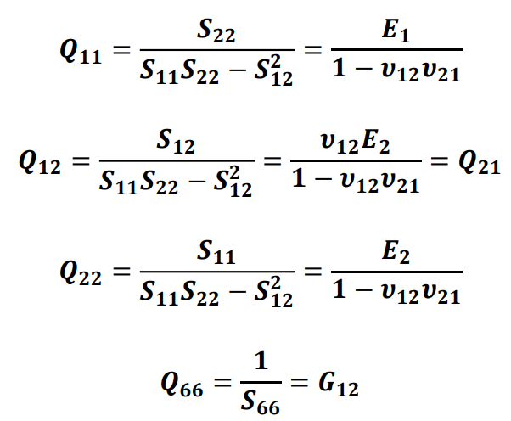

To make matrix calculations slightly easier, these equations and all following ones for the worked problems were computed in MATLAB. (Note: v21 = (E2/E1) * v12)

These values equate to be:

$$Q_{11}=121.6302 GPa, Q_{12}=2.3341 GPa, Q_{22}=8.6448 GPa, Q_{66}=4.7 GPa$$

Using these values, the transformed Lamina Stiffness Matrices can be calculated, where this only needs to be done for the 30° fibre orientation. This is done using the following equations:

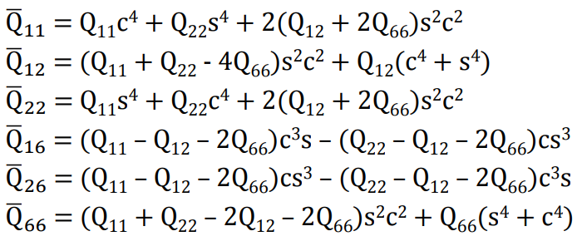

Where ‘s’ and ‘c’ equal sin(θ) and cos(θ) respectively.

This was calculated in the following way in MATLAB:

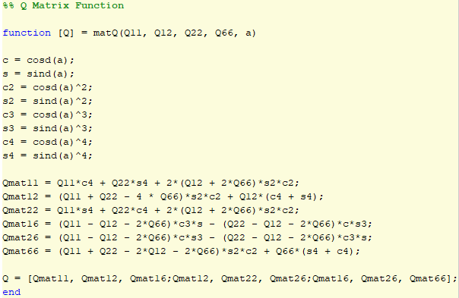

Making the 0° Lamina Stiffness Matrix equal:

$$Q_{0}=\left[\begin{matrix}121.6302 & 2.3341 & 0 \\ 2.3341 & 8.6448 & 0 \\ 0 & 0 & 4.7\end{matrix}\right]GPa$$

And the 30° Lamina Stiffness Matrix equal:

$$Q_{30}=\left[\begin{matrix}73.3576 & 22.3604 & 36.0242 \\ 22.3604 & 16.8649 & 12.8999 \\ 36.0242 & 12.8999 & 24.7263\end{matrix}\right]GPa$$

The full CLT Stiffness Matrix takes the form of:

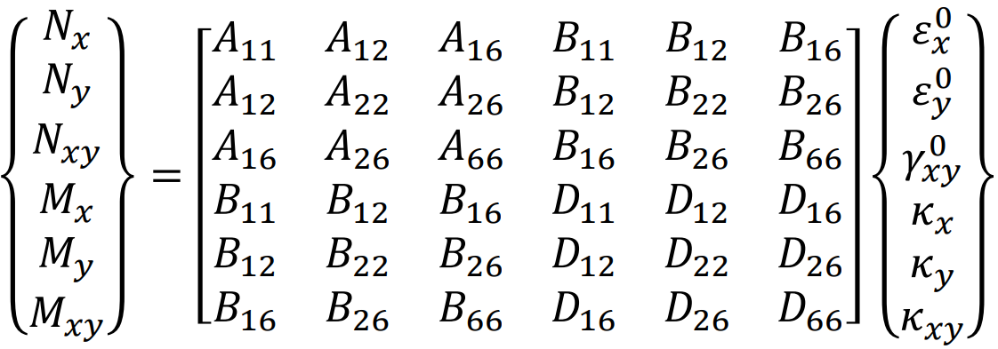

However, because this laminate is symmetrical, all B terms will work out to be zero. This split the matrix into two separate matrices of the forms:

$N=Aε$, and $M=DK$

Though, because N = 0 and the rows of A are all linearly independent, then the strain vector: ε must also have all zero entries.

Simplifying the problem, to just the M = DK, equation. Calculating the D matrix is done via the following equation:

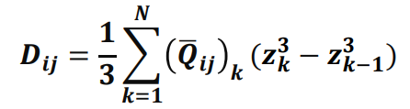

Therefore, the D Matrix becomes:

$$D=\left[\begin{matrix}9.633 & 0.4031 & 0.3753 \\ 0.4031 & 0.8060 & 0.1344 \\ 0.3573 & 0.1344 & 0.6003\end{matrix}\right]GPa {mm}^{3}$$

Since My and Mxy are both zero, and all rows of D are linearly independent then only one value of curvature is needed to solve for Mx. These curvatures can be solved for by using the relationship between curvature and lamina strain:

$$ε_{x}={ε_{x}}^{0}+zK_{x}$$

And because we know that εx0 is zero, the strain in each lamina is solely dependent on how far away it is from middle plane, which makes sense as there is only a moment being applied about the x-axis.

Based on the maximum strain criterion, the smallest ultimate strain value should result in the first ply failure. However, the provided strain values correspond the tensile and compressive loads with respect to the fibre direction. Hence these values must be translated to the global axis for the 30° fibre orientation. This done via the following equation:

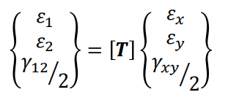

Where T is equal to:

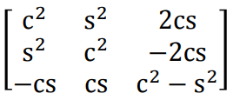

Where ‘s’ and ‘c’ equal sin(θ) and cos(θ) respectively.

Therefore, to translate the ultimate strains to from their 30° frame the following equation was solved:

$$\left\{\begin{matrix}ε_{x} \\ ε_{y} \\ ε_{xy/2}\end{matrix}\right\}={\left[T\right]}^{-1}\left\{\begin{matrix}ε_{1} \\ ε_{2} \\ ε_{12/2}\end{matrix}\right\}$$

Because exact strains were not known, each solution was solved for the 0° scenario and then the results were used in this transformation and fed back, into the equation to solve again.

Hence to solve for the moment Mx the following matrix equation was solved, where this example is for a longitudinal tensile case, corresponding to the x-direction:

$$\frac{-{e_{L}}^{\left(+\right)}}{z}\left\{\begin{matrix}D_{11} \\ D_{12} \\ D_{16}\end{matrix}\right\}=\left[\begin{matrix}-1 & D_{12} & D_{16} \\ 0 & D_{22} & D_{26} \\ 0 & D_{26} & D_{66}\end{matrix}\right]\left\{\begin{matrix}M_{x} \\ K_{y} \\ K_{xy}\end{matrix}\right\}$$

Therefore, to find the mode of first ply failure, the lamina it occurs and the maximum bending moment; the minimum value of this bending can be found from varying the ultimate strain, the laminate distance z and the corresponding lamina fibre angle.

Using this the following results were found (Note only two layers are needed as the values on the other side of the middle plane will be the same but reversed sign):

|  |  |  |  |  |  |
| --- | --- | --- | --- | --- | --- |
|  | $${e_{L}}^{\left(+\right)}$$ | $${e_{L}}^{\left(-\right)}$$ | $${e_{T}}^{\left(+\right)}$$ | $${e_{T}}^{\left(-\right)}$$ | $$e_{LT}$$ |
| Layer 1: 0° (z = -0.5mm) | -309.52MPa mm2 | -200.17MPa mm2 | 144.22MPa mm2 | 865.30MPa mm2 | 417.23MPa mm2 |
| Layer 2: 30° (z = -0.25mm) | 117.58MPa mm2 | -400.22MPa mm2 | -120.90MPa mm2 | -725.41MPa mm2 | 1165.19MPa mm2 |

This means that the maximum bending moment before first ply failure for the [0/30]s laminate is approximately, 117.58MPa mm2, where this will occur in one of the two middle 30° laminas and will fail via tensile strain in the direction of the fibres.

1. Using the exact same methodology as in part a, therefore, resulting in a different D matrix; the following bending moments were found now using the [30/0]s laminate:

|  |  |  |  |  |  |
| --- | --- | --- | --- | --- | --- |
|  | $${e_{L}}^{\left(+\right)}$$ | $${e_{L}}^{\left(-\right)}$$ | $${e_{T}}^{\left(+\right)}$$ | $${e_{T}}^{\left(-\right)}$$ | $$e_{LT}$$ |
| Layer 1: 30° (z = -0.5mm) | 44.56MPa mm2 | -42.31MPa mm2 | -60.49MPa mm2 | -362.92MPa mm2 | 40.03MPa mm2 |
| Layer 2: 0° (z = -0.25mm) | -184.92MPa mm2 | -119.58MPa mm2 | 93.06MPa mm2 | 558.38MPa mm2 | 108.46MPa mm2 |

This means that the maximum bending moment before first ply failure for the [30/0]s laminate is approximately, 40.03MPa mm2, where this will occur in one of the two outer 30° laminas and will fail via shear strain.

For reference: these are the two D matrices found for each of the two laminates:

D [0/30]s =



D [30/0]s =



1. Overall the [0/30]s performs better in every scenario according to the tables in part a and b. Bearing in mind that this example is only accounting for the bending moment about the wings x axis. Because this is a moment, it makes sense that the further away from the middle plane, the higher the stresses and strains will be on that laminate layer. The tables indicate the 30° layer is not as well equipped in dealing with this specific load as it is off-axis and the strongest composite direction is almost always along the direction of the fibres. The 30° layers instead prevent the material from being completely subject to its weak transverse properties. This why the positioning the 0° layers on the outside of the composite makes more sense in this scenario and the calculations prove this.
2. With the maximum normalised bending moment (Mx) being 120 MPa mm2, this puts for factor of safety for the [0/30]s at around 0.98, and the factor of safety for the [30/0]s laminate at around 0.33, making the [0/30]s the obvious choice though still in need of major improvements to be used on commercial aircraft where redundancies high safety takes high importance.

## Question 2:

1. First calculating the principal hygrothermal strains uses the following equation:



This equation can be used as the material is not restrained during hygrothermal exposure. Using the provided coefficients of thermal expansion and coefficients of hygroscopic expansion, these values equate to:

$$ε_{h1}=α_{1}×∆T+β_{1}$$

$$ε_{h2}=α_{2}×∆T+β_{2}$$

$$ε_{h1}=-0.47×{10}^{-6}×\left(20-120\right)+0.09≈0.09$$

$$ε_{h2}=30×{10}^{-6}×\left(20-120\right)+0.3≈0.297$$

Then using the same equation of strain transformation as before:

$$\left\{\begin{matrix}ε_{x} \\ ε_{y} \\ ε_{xy/2}\end{matrix}\right\}={\left[T\right]}^{-1}\left\{\begin{matrix}ε_{1} \\ ε_{2} \\ ε_{12/2}\end{matrix}\right\}$$

Where ε12 = 0, to calculate these values at 30° gives the following values:

$$ε_{x}=0.1418$$

$$ε_{y}=0.2453$$

$$ε_{xy}=0.0896$$

Though the materials’ properties will have now slightly changed to the added moisture content, which equates to the following percentage, based on 5% added moisture content:

$$w_{\%}=1-\frac{1}{1.05}=0.0476$$

Which is used the following set of equations:



Where, Mr = the weight percent of moisture.

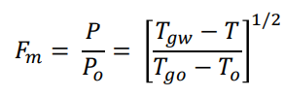

Although this degradation factor of material stiffness and strength properties is based solely on the matrix portion of these parameters, it is assumed it will apply to the whole composite as the fibre-volume fraction is not known. The rest of the variables in this equation are all related to temperature and are defined as follows:

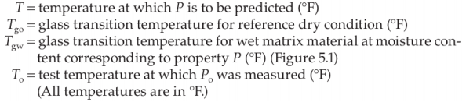

Though for this example, Celsius was used.

This makes the degradation equal to approximately: 0.997, which is multiplied by the existing strength parameters to simulate their degradation due to the added moisture.

Finally using the principal of superposition, hygrothermal strains can be added to the ultimate strains at the lamina level (using the correct values for the different fibre orientations) used in the first question to determine the new maximum bending moment about the x axis before first failure, the mode of failure and the lamina that failed. Using the same methods as in question 1 (CLT and maximum strain criterion), the following results were obtained for the [0/30]s laminate:

$$Maximum bending moment≈415.98MPa$$

$$Mode of Failure=Shear Strain Failure$$

$$Failed Lamina=Either of the outer 0° lamina$$

1. The same technique was applied to the [30/0]s laminate for the following results:
$$Maximum bending moment≈108.14MPa$$

$$Mode of Failure=Shear Strain Failure$$

$$Failed Lamina=Either of the inner 0° lamina$$

2. It can be seen that proper curing techniques can greatly improve a materials’ quality and property and these results further prove this fact. In both cases now the 0° lamina are the first ply to fail, most likely due to the fact there is no hygrothermal strain the principal shear direction, making this direction less resistant to strains.

Important Note: I am aware that the values presented in this report for the maximum bending moment, though in the correct order of magnitude, are most likely wrong. This is due to my strain/curvature calculations as I spent far too attempting to relate these in a way that made sense, along with translating the ultimate strains into the 30° direction. I have included my MATLAB code for reference of what I did, to show as much working as I can.

# ANSYS Deliverables

## Deliverable 1:

## 1.

Blah

Table :Antisymmetric Angle-Ply Laminate Design Metrics for Minimum Wing Twist

|  |  |  |  |  |  |  |
| --- | --- | --- | --- | --- | --- | --- |
| Ply Angle  α | Stacking Sequence | Factor of Safety | Wing Twist Angle  β | Wing Tip Deflection (mm) | Mass  (g) | Cost  ($) |
| 15° |  |  |  |  |  |  |

Blah

FIGURE CLT MATRIX

FIGURE LAMINATE CROSS-SECTION

## 2.

No, and include brief reference to Table 1 and explanation

## 3.

Blah

## Deliverable 2:

Blah

# Code Appendix

%% Parameters

% Material Paramters

E1 = 121; % GPa

E2 = 8.6; % GPa

v12 = 0.27;

v21 = (E2 / E1) * v12;

G12 = 4.7; % GPa

t = 0.25; % mm

% Degradation due to mositure content

Mr = 0.05;

Tgo = 120;

Tgw = (0.005*Mr^2 - 0.1*Mr + 1)* Tgo;

Frac = ((Tgw-20)/(Tgo-20))^0.5;

E1 = E1*Frac;

E2 = E2*Frac;

G12 = G12*Frac;

laminate1 = [0,30,30,0]; % degrees

laminate2 = [30,0,0,30]; % degrees

sizeL = size(laminate1, 2);

zarray = linspace(-t*(sizeL/2), t*(sizeL/2), sizeL + 1);

% Maximum Stain Criterion

eLpos = 0.0167;

eLneg = 0.0108;

eTpos = 0.0032;

eTneg = 0.0192;

eLT = 0.012;

% Calculate Q Values

Q11 = E1 / (1 - v12 * v21);

Q12 = (v12 * E2) / (1 - v12 * v21);

Q22 = E2 / (1 - v12 * v21);

Q66 = G12;

Q0 = matQ(Q11, Q12, Q22, Q66, 0);

Q30 = matQ(Q11, Q12, Q22, Q66, 30);

A1 = SumMat(Q0, Q30, Q30, Q0, 'A', zarray);

A2 = SumMat(Q30, Q0, Q0, Q30, 'A', zarray);

B1 = SumMat(Q0, Q30, Q30, Q0, 'B', zarray);

B2 = SumMat(Q30, Q0, Q0, Q30, 'B', zarray);

D1 = SumMat(Q0, Q30, Q30, Q0, 'D', zarray);

D2 = SumMat(Q30, Q0, Q0, Q30, 'D', zarray);

%% Hygrothermal Section

a1 = -0.47e-6;

a2 = 30e-6;

b1 = 0.09;

b2 = 0.3;

T1 = 120;

T2 = 20;

CT = T2 - T1;

% hygro strains 0 degrees

he1 = a1*CT + b1;

he2 = a2*CT + b2;

% hygro strains 30 degrees

h30x = trans30(he1,he2,0,1);

h30y = trans30(he1,he2,0,2);

h30xy = trans30(he1,he2,0,3);

%% Final Moment Calculations

% Lam = 0,30,30,0

M1 = strain(eLpos,eLneg,eTpos,eTneg,eLT,D1,-0.5,0, he1, he2, h30x, h30y, h30xy);

M2 = strain(eLpos,eLneg,eTpos,eTneg,eLT,D1,-0.25,1, he1, he2, h30x, h30y, h30xy);

% Lam = 30,0,0,30

M3 = strain(eLpos,eLneg,eTpos,eTneg,eLT,D2,-0.5,1, he1, he2, h30x, h30y, h30xy);

M4 = strain(eLpos,eLneg,eTpos,eTneg,eLT,D2,-0.25,0, he1, he2, h30x, h30y, h30xy);

%% Q Matrix Function

function [Q] = matQ(Q11, Q12, Q22, Q66, a)

c = cosd(a);

s = sind(a);

c2 = cosd(a)^2;

s2 = sind(a)^2;

c3 = cosd(a)^3;

s3 = sind(a)^3;

c4 = cosd(a)^4;

s4 = sind(a)^4;

Qmat11 = Q11*c4 + Q22*s4 + 2*(Q12 + 2*Q66)*s2*c2;

Qmat12 = (Q11 + Q22 - 4 * Q66)*s2*c2 + Q12*(c4 + s4);

Qmat22 = Q11*s4 + Q22*c4 + 2*(Q12 + 2*Q66)*s2*c2;

Qmat16 = (Q11 - Q12 - 2*Q66)*c3*s - (Q22 - Q12 - 2*Q66)*c*s3;

Qmat26 = (Q11 - Q12 - 2*Q66)*c*s3 - (Q22 - Q12 - 2*Q66)*c3*s;

Qmat66 = (Q11 + Q22 - 2*Q12 - 2*Q66)*s2*c2 + Q66*(s4 + c4);

Q = [Qmat11, Qmat12, Qmat16;Qmat12, Qmat22, Qmat26;Qmat16, Qmat26, Qmat66];

end

%% Quadrant Matrix Function

function QuadMat = SumMat(Q1, Q2, Q3, Q4, quad, zarray)

% Determines what quadrant we are in

if quad == 'A'

p = 1;

elseif quad == 'B'

p = 2;

elseif quad == 'D'

p = 3;

else

disp('invalid input')

end

% Matrix Summing

QuadMat = Q1* (zarray(2)^p - zarray(1)^p) + Q2 * (zarray(3)^p - zarray(2)^p) + Q3 * (zarray(4)^p - zarray(3)^p) + Q4 * (zarray(5)^p - zarray(4)^p);

QuadMat = QuadMat*(1/p);

end

%% Strain Function

function [M] = strain(lx, ly, tx, ty, xy, D, z, deg, he1, he2, h30x, h30y, h30xy)

lx = (lx + he1)/z;

ly = (ly + he1)/z;

tx = (tx + he2)/z;

ty = (ty + he2)/z;

xy = xy/z;

M = zeros (1,5);

Mcol = [-1;0;0];

Klx = D(:,1)*-lx;

Dlx = D;

Dlx(:,1) = Mcol;

LX = Dlx\Klx;

if deg == 1

x_lx = trans30(tx*z,LX(2)*z,LX(3)*z,1);

x_lx = (x_lx + h30x)/z;

Klx = D(:,1)*-x_lx;

LX = Dlx\Klx;

end

M(1) = LX(1)*1000;

Kly = D(:,1)*-ly;

Dly = D;

Dly(:,1) = Mcol;

LY = Dly\Kly;

if deg == 1

x_ly = trans30(ty*z,LY(2)*z,LY(3)*z,1);

x_ly = (x_ly + h30x)/z;

Kly = D(:,1)*-x_ly;

LY = Dly\Kly;

end

M(2) = LY(1)*1000;

Ktx = D(:,2)*-tx;

Dtx = D;

Dtx(:,2) = Mcol;

TX = Dtx\Ktx;

if deg == 1

x_tx = trans30(TX(1)*z,tx*z,TX(3)*z,2);

x_tx = (x_tx + h30y)/z;

Ktx = D(:,2)*-x_tx;

TX = Dtx\Ktx;

end

M(3) = TX(2)*1000;

Kty = D(:,2)*-ty;

Dty = D;

Dty(:,2) = Mcol;

TY = Dty\Kty;

if deg == 1

x_ty = trans30(TY(1)*z,ty*z,TY(3)*z,2);

x_ty = (x_ty + h30y)/z;

Kty = D(:,2)*-x_ty;

TY = Dty\Kty;

end

M(4) = TY(2)*1000;

Kxy = D(:,3)*-xy;

Dxy = D;

Dxy(:,3) = Mcol;

XY = Dxy\Kxy;

if deg == 1

x_xy = trans30(XY(1)*z,XY(2)*z,xy*z,3);

x_xy = (x_xy + h30xy)/z;

Kxy = D(:,3)*-x_xy;

XY = Dxy\Kxy;

end

M(5) = XY(3)*1000;

end

%% Inverse Transformation

function [sol30] = trans30(x, y, xy, num)

a = 30;

c = cosd(a);

s = sind(a);

c2 = cosd(a)^2;

s2 = sind(a)^2;

T = [c2,s2,-2*c*s;s2,c2,2*c*s;c*s,-c*s,c2-s2];

vec = [x;y;0.5*xy];

sol = T\vec;

if num == 1

sol30 = sol(1);

elseif num == 2

sol30 = sol(2);

elseif num == 3

sol30 = sol(3);

end

end